**VM Machine Description**

Virtual Machine Name: QBYMSQVDC001

Memory: 2048 Mb

Virtual Disk: qbymsqvdc001.vmdk (Max Size: 250 GB)

Operation System: Oracle Linux 6.1

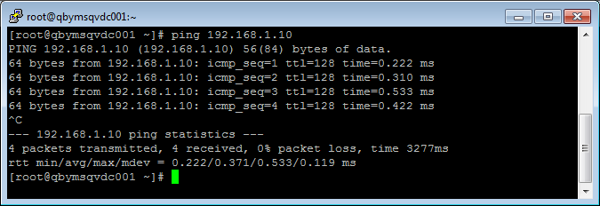

vi /home/oracle/.bash_profile

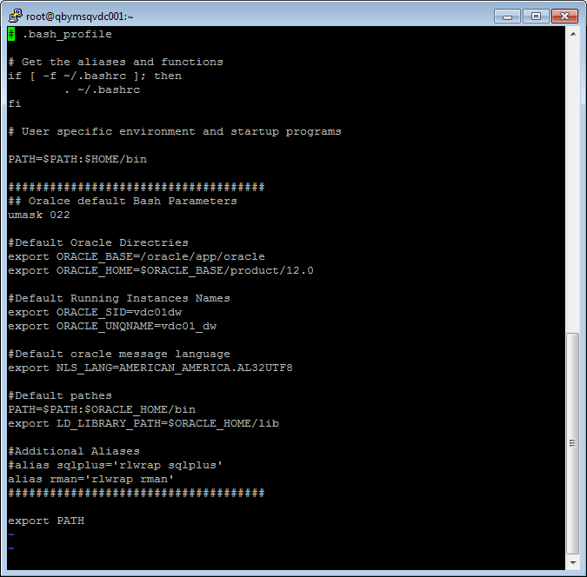

**Install Oracle 11G R2**



